Array list->

1.resizalbe array is –is ;

2.duplicates are allowed;

3.insertion order preserved;

*4.hetrogenous object can allowed exept [tree set and tree map every where it allow]->except duplicates;

5.null insertion is possible.

Constructors->

1.ArrayList ls -> ArrayList();->

Creat an empty array list object with default initial capacity10.

If we exceed the limit of array lik 10 and we insert -11 so it make new array and insert all elemnts then capectiy will be->

New capacity=(cc*3/2)+1;

2.ArrayList l =new ArrayList(int initialcapacity);

->its for 1000 object by above formula it takes too much time so we have use this;

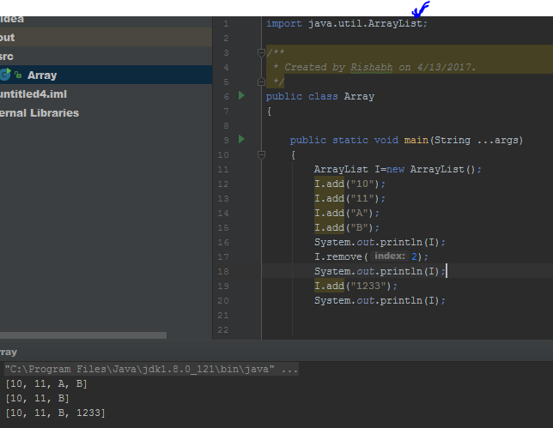

3.ArrayList l-new ArrayList(collection c);

-> I want a linklist by array then this we will be use.its for any collection ->linked list and vector.

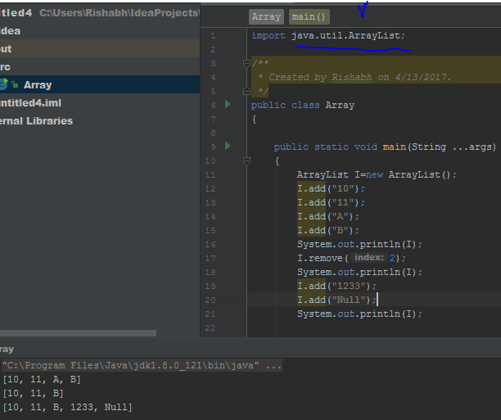

**Container->**

A container is a holder object that stores a collection of other objects (its elements). They are implemented as class templates, which allows a great flexibility in the types supported as elements.

To hold data across netwrk.

->array,vector……

Like container in c++ we use collection java.

Cloning->

Means duplicating;

Usually we



Al and vector implements random access because any element we can access in same time ..either its 100corerth element or first element.

RandomAccess (i)->present in utill package.

->Arraylist best for frequent operation retrieval operation.

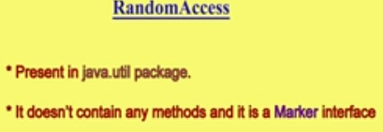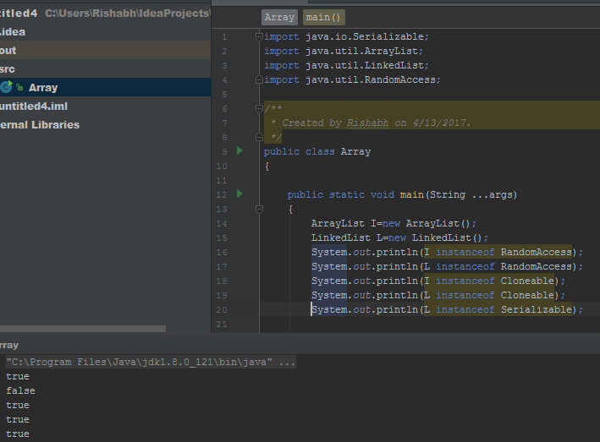

Where the array list is wrost choice->

When we insert element in middle then it will take too much time..for 1000 corore element.

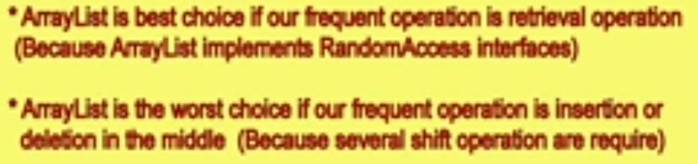

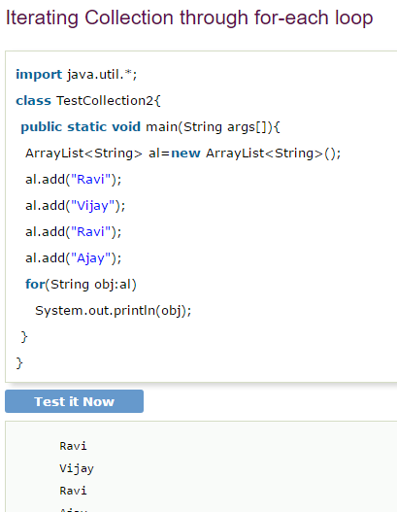

User-defined class objects in Java ArrayList->

